
Large Antique Enamel Box - Poss. French or Staffordshire Battersea Bilston
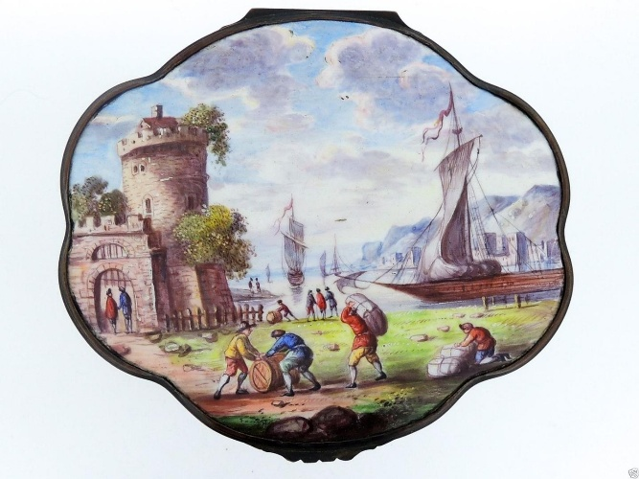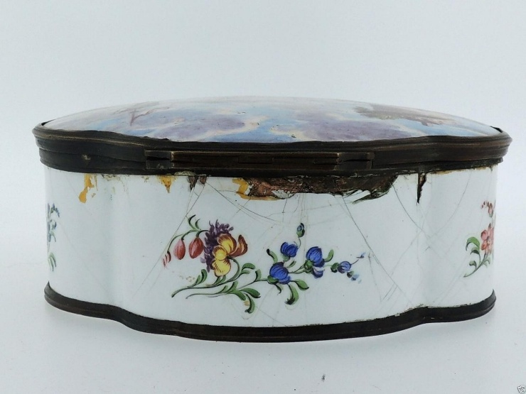

Pricing & History
- Sold for $1,235.00
- Sold Date: May 22, 2017
- Source: Online Marketplace
- Worthpoint Category: Uncategorized
- Original Category Antiques: Decorative Arts:Other Antique Decorative Arts
Offered here for your consideration is a Large Antique Enamel Box. It dates from mid 19th century or earlier. Alas, it is not in perfect condition with cracks and fissures throughout. The mount has an old reglue and the lid does not stay shut (likely from a small bend). There are losses to the enamel near the hinge on the exterior and in the interior (as well as in a few other spots.) Otherwise, there are surface scratches and scuffing throughout and other signs of light wear consistent with age. Measurements: Height: 2 in. Width: 5-1/2 in. Depth: 4-3/4 in.

